Measuring Board Impact on Hospital Finance and Quality

Abstract

Boards are a powerful resource in overseeing our health system. This resource is limited in the amount of available time; therefore, boards should be as productive as possible. Where boards focus their energy should have tangible, measurable results. Using Natural Language Processing (NLP) tools and quantitive outcome measures allow us to measure the impact of their focus. This analysis finds no significant relationship between an increased focus on finance or quality from the board minutes and organizational performance in finance or quality. Boards focus much more on finance than quality with no substantive difference in outcomes. The study indicates that boards may need to revise their approach and allocation of time to these topics.

Introduction

In Ontario, Hospital Boards are at the apex of complex organizations and are responsible to their communities and government for ensuring high-quality care and efficient use of resources. Boards have several critical roles in an organization (Corbet and Pessione 2019; Quigley and Scott 2004). These include the general fiduciary responsibilities, responsibility for organizational leadership, strategic oversight and quality, which is now a significant, legally mandated requirement of the board as outlined in the Ontario Excellent Care for All Act (ECFAA) and The People's Health Care Act, 2019. Finance is a more traditional focus for hospital boards stemming from the board's duty of care and responsibility for financial oversight. (Corbet, A. 2013). Ontario hospital Board sign-off is required on the HQO quality indicators report and the Ontario Health/LHIN performance agreements, which include financial targets. In both areas, the Boards role is to certify the plans and oversee compliance. Management is responsible for the detailed steps.

In its (2008 report), The Ontario Auditor-General indicated a need for boards to compare performance with other boards. Interestingly, peer-to-peer comparisons are commonly available and used to improve performance throughout the hospital. However, peer-to-peer board comparisons are not available and would give the board a powerful way to measure and improve its performance.

There are no known quantitive tools to measure hospital board performance in a data-driven manner (Hooper 2020). There are best practice guidelines, board self-assessments and numerous consultants who can advise boards on practice, but hospital boards cannot quantitively compare their board performance with their peers.

Quantitative tools give board members and other stakeholders reproducible methods to help compare what they are doing with other boards. The methodology described in this article is the first known quantitive peer-to-peer comparison tool for boards.

Analytical Process

(Hooper 2020) showed that board focus and intensity could be identified and quantified from the board minutes. The data set used for that work has been doubled in this study from 700 to 1,500 board meetings in 36 Ontario hospitals (10 teaching hospitals, 17 large community hospitals and nine small hospitals). The overall Riverbed distribution of board focus is shown in Figure 1 below. The graph shows the average percentile rank for each focus area and the variation around that area. Hospital Boards spend time in various other areas, but the 16 shown below are consistent across all hospitals.

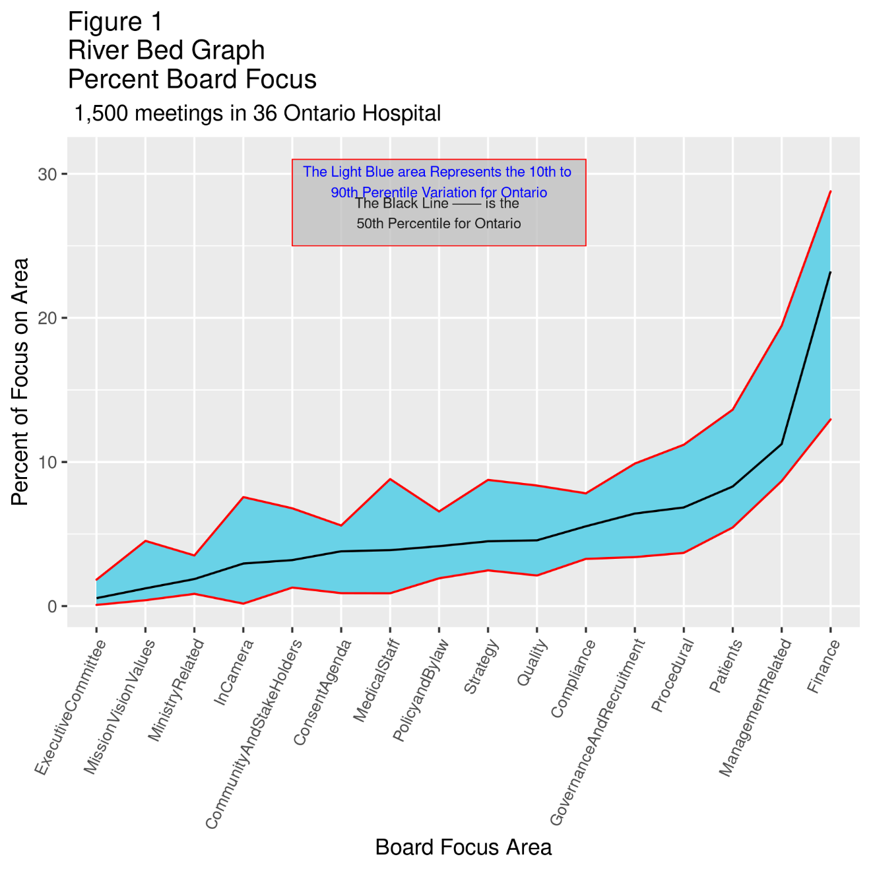

The Board focus data set is based on publicly available board minutes. Individual hospital minutes were processed in a standard method using the generally accepted tools for text analysis. The processing included lemmatization, removal of stop words, various tokenization methodologies and the Latent Dirichlet Allocation (LDA) methodology, which facilitated the selection of board foci and terms associated with those foci (Hooper 2020). The foci are indexed to board meeting length to create a standardized comparator.

Finance and Quality Outcomes

This analysis focused on determining if there is a relationship between board focus on finance and quality and measurable improvements in relevant outcomes. Specifically, does increasing board focus on a topic improve overall performance in that area. Finance and quality were chosen as both are key outcome areas for all Ontario Hospitals.

Although finance and quality are critical responsibilities, most boards spend much less time on quality than other areas and significantly less than finance. Finance is the number one focus area for almost all boards. Figure 2 below shows the variation by type of hospital for finance and quality. On average, hospitals are about six times more focused on finance than quality regardless of facility type. In his article on hospital governance, Carruthers (2019) argues that board membership is insufficiently weighted with hospital/clinical expertise.

A review of 108 board member bio's in 6 of the 36 hospitals (2 Teaching, 2 Large Community, and 2 Small hospitals) indicated that board members were predominantly from the business arena 42%. The next largest group was ex-offico staff, consisting of MAC presidents, medical staff presidents, University appointments and CNO's 36%. Board members with clinical expertise who were not managers constituted 2%. The remaining 20% were mainly from the not-for-profit arena. The data also seemed to show that increasing financial board members increases the focus on finance.

Figure 2
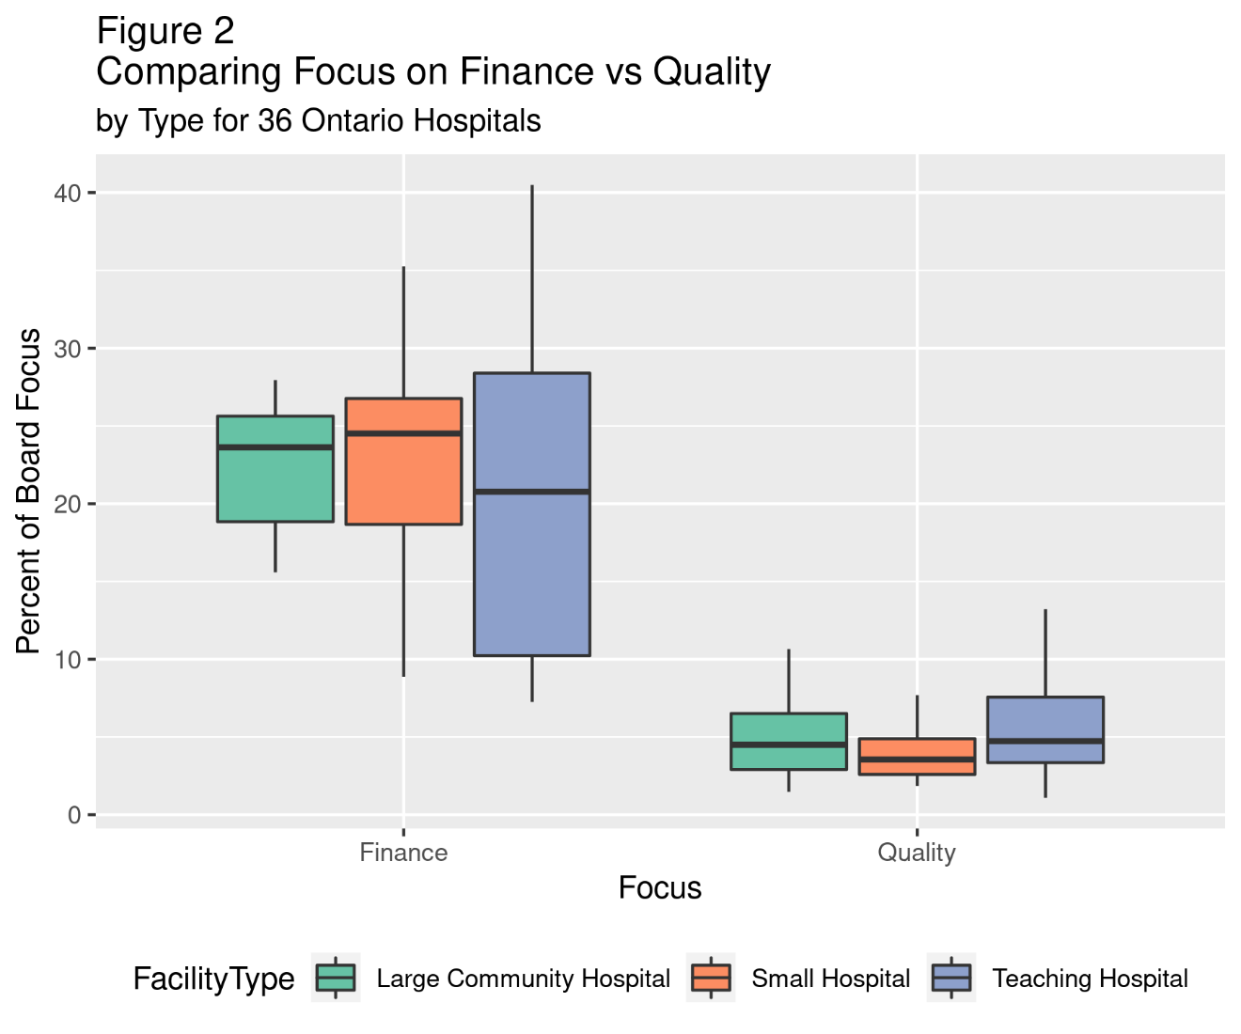

Outcome Measures

We might expect those boards with a higher focus on an area to show better outcomes. The board focus data and the outcome data from the Ontario Ministry of Health (MOH) and the Canadian Institute for Health Information (CIHI) were matched on a year-by-year basis. The impact of focus on outcomes was reviewed for all hospitals as a group and then segmented by facility type (Small Hospital, Large Community Hospital and Teaching Hospital).

Overall, ten outcome measures, five for finance and five for quality, were tested. Each measure was regressed against the appropriate focus area (quality or finance) first for the overall group of 36 hospitals, then by facility type. One of the quality measures is not available for small hospitals. Thus, there were a total of 39 tests looking to determine if increasing Board focus had a significant impact on a measurable outcome.
The data set for the simple linear regressions that follow varied from an overall group high of 140 data points to a low of 33 for small hospitals. According to (Jenkins 2020), the minimum sample size for simple linear regressions is 25 data points. Thus all the regressions appear to be of a reasonable size. A post hoc statistical power analysis also indicates that the sample size is appropriate to detect a meaningful impact.

The output of the analysis for each measure is divided into three categories:
- Beneficial and Statistically Significant: a p-value <=0.05 indicates a statistically significant result, and the regression slope shows the increased focus had a beneficial impact on the outcome measure. A beneficial slope can be either up or down, depending on the measure.
- Not beneficial but significant: A p-value <=0.5 indicates a statistically significant result, but the regression slope shows that increasing board focus did not improve the outcome measures.
- Statistically non-significant: A p-value >0.05 indicates there is no statistically significant relationship between the Board focus and the outcome measures

For example, when looking at operating margin and board focus on finance, we might expect an increased focus on finance to show a statistically significant improvement in operating margin. This result would be Beneficial and Statistically Significant. The two other potential outcomes would be Statistically Not Significant if the p value>0.05 or Not beneficial but significant, indicating a statistically significant result, but the increased focus on finance is associated with a decreased Operating Margin.
Hospitals are complex entities, and many factors can impact these outcome measures. Therefore, the R^2 may be lower than usual, but there should be some measurable return on the investment of time by board members and the staff who support them.

The measures chosen in Finance and Quality are standard measures used in hospitals. The measures are easily understood and are influenceable, e.g., the measure can be changed by actions taken by the hospital.

Finance

For finance, the five measures selected were:
1) Percent Operating Margin,
2) Working Capital as a Percent of Total Revenue,
3) Current Ratio
4) The CIHI Corporate Services Expense Ratio and
5 The CIHI Cost of a Standard Hospital Day.

Overall, for the 36 hospitals as a group, regressing the percent of board focus on finance with the measures outlined above found no statistically significant relationship. See the first column in Table 1 below.

Results for Finance by Facility Type

It can be argued that a particular facility type (small hospital, large community hospital or teaching hospital) may have differing capacities to influence outcomes. The data set for each hospital type is somewhat smaller but still constitutes an acceptable set of data. However, the smaller set may indicate a decreased ability to detect minor effects based on statistical power analysis.
Using the methods outlined above and comparing focus by facility type with the selected measures creates fifteen tests. These results by facility type are shown in Table 1

Table 1
Board Focus Area | Measure | All Hospitals | Teaching Hospitals | Large Community Hospitals | Small Hospitals
Finance | Corporate Services Expense Ratio | No Significance found p-value >0.05 | No Significance found p-value >0.05 | Not Beneficial  But significant p=0.0108 | Beneficial and Significant p=0.007.
Finance | Cost of Standard Hospital Stay | No Significance found p-value >0.05 | Not Beneficial  But significant p=0.001 | No Significance found p-value >0.05 | Beneficial and Significant p=0.0225.
Finance | Current Ratio | No Significance found p-value >0.05 | No Significance found p-value >0.05 | No Significance found p-value >0.05 | No Significance found p-value >0.05
Finance | Operating Margin | No Significance found p-value >0.05 | No Significance found p-value >0.05 | Not Beneficial  But significant p=.0133 | No Significance found p-value >0.05
Finance | Percent Working Capital | No Significance found p-value >0.05 | No Significance found p-value >0.05 | No Significance found p-value >0.05 | No Significance found p-value >0.05

Finance Summary Results

Looking at the results for All Hospitals finds no link between increasing board focus on finance and outcomes.

The fact that the two significant and beneficial results are both in small hospitals is interesting. There are several hypothetical explanations as to why small hospital boards appear to have a positive impact on those two areas
- Board members in small hospitals may have skills and experience that are required but not be available in small hospitals management
- Perhaps small hospitals are still mining the efficiencies that large community hospitals and teaching hospitals have removed
- The relationship between the board and staff in small hospitals may be closer in some way. Allowing for better-shared knowledge, or
- Given there are twenty measures under review, we might expect that some of the positive and negative outcomes are simply happening by chance and that the positive instance for small hospitals is a random outcome
There is no evidence to support any of these explanations, but this is an area where further study may be helpful.

What is apparent is that, with the possible exception of small hospitals, increased board focus on finance has little positive impact on a hospital's financial performance, and the net effect across all hospitals is not beneficial.

In summary, Figure 1 shows that boards spend approximately 25% of their time focused on finance on average. Table 1 indicates that increasing focus on finance has minimal impact on financial performance. Thus, boards with a high focus on finance may wish to reallocate their limited time.

Quality

For quality, the five measures selected were:
1) The Hospital Readmission Rate for all causes,
2) The Wait Time for Physician Assessment in Emergency,
3) Wait Time in Emergency
4) The Hospital Standardized Mortality Rate (HSMR), and
5) The Adjusted Hospital Sepsis Rate.

There is a concern that some of these quality measures may be more difficult for the organization to change than others, and for some, there is an unclear picture of what is an acceptable target. Specifically, there has been debate on HSMR rates (Penfold et al., 2008). Nevertheless, some hospitals (Ottawa Civic 2021) have indicated success in reducing their rates. The degree to which the above quality measures are influenceable by the organization is a concern, but there is value in looking at these as a group of measures. In addition, the long-term trend of all these measures shows an overall improvement across Ontario. Thus, as frequently happens, measuring improves performance despite the concerns about the measures.

As was done with finance above, the relationship between the board focus on quality and the organization's performance for each outcome measure was analyzed using a simple regression between the percent of the focus on quality and the outcome measure for each year of hospital data available.

Small hospitals do not generally report HSMR data, so there are only 19 data elements for quality.

Results for Quality

Overall results for the 36 hospitals as a group found no beneficial link between the boards' focus on quality and any outcome measure. There was a statistically significant but non-beneficial result concerning HSMR. For that measure, increased board focus is statistically linked to increased HSMR. This may mean boards with higher scores are aware of and discuss quality issues at a higher rate than others, but a higher focus on the problem doesn't affect the result. (See the first column in table 2 below)

Results for Quality by Facility Type

Looking at the data by facility type, we see that there appears to be one beneficial link between focus on quality and improvements in hospital readmission rates in large community hospitals. However, all other results are either not beneficial(3) or not significant15.

Table Two
Board Focus Area | Measure | All Hospitals | Teaching Hospitals | Large Community Hospitals | Small Hospitals
Quality | Hospital Readmission Rate | No Significance found p-value >0.05 | No Significance found p-value >0.05 | Beneficial and Significant p=0.0311. | No Significance found p-value >0.05
Quality | Time for Initial physician assessment in Emergency | No Significance found p-value >0.05 | No Significance found p-value >0.05 | No Significance found p-value >0.05 | No Significance found p-value >0.05
Quality | Time Spent in Emergency | No Significance found p-value >0.05 | No Significance found p-value >0.05 | No Significance found p-value >0.05 | Not Beneficial  But significant p=0.001,
Quality | HSMR | Not Beneficial  But significant p=0.003 | Not Beneficial  But significant p=0.001 | No Significance found p-value >0.05 | No Data
Quality | Hospital Sepsis | No Significance found p-value >0.05 | No Significance found p-value >0.05 | No Significance found p-value >0.05 | No Significance found p-value >0.05

Summary Quality

As was noted with finance, there is almost no link between the board's focus on quality and organizational performance. The one exception is for large community hospitals and hospital readmission rates.

Assumptions.

A fundamental assumption made in this work is that board minutes accurately reflect the discussion and decisions of the board. There is variation in the length of minutes, and a small number of boards minutes reflect a "dollars, decisions, and deadlines" approach, and their minutes are shorter. However, the riverbed graph of their hospital's focus is quite similar to the pattern seen in Figure 1 above.
It is also possible that the board minutes are sanitized or slanted, thus clouding or enhancing the focus. But it seems unlikely that board members in 36 hospitals over several years of service would not insist that the minutes accurately reflect the board's discussions. And it is assumed that if this is happening, it is only in a small number of boards for a limited time and is not a consistent pattern among Ontario Hospital Boards.

Limitations

This study is limited to publicly available information from the full board meetings. It does not include information from board subcommittees (finance, quality or others) or in-camera meetings of the entire board; that data may impact the overall results.

Because not all hospitals publish their board minutes and some only maintain a couple of years of minutes on their websites, a time series analysis is not possible. A time-series analysis may show a different relationship.

The impact of board mix on focus is unclear, but observational evidence indicates that the mix of member types drives board focus.

The text analysis and machine learning tools used in this analysis are new, and validation and modification of the techniques may be required.

Potential next steps.

A more detailed analysis of the Board Member bios may show the need for more careful consideration of board mix. Specifically, does member expertise drive board focus.

A high board focus in an area may drive management to spend more time on that area outside of its normal board support process. A study of how much board focus drives the amount of time management spends on an area may multiply the unproductive value of the increased focus.

A review of the impact of Board committees in Finance and Quality may show a more direct impact on outcomes. But that data is not generally publicly available.

A validation study to confirm that the derived board focus from the minutes accurately reflects the discussions and actions of the board could be done. This study could include observations in a board meeting and interviews with board members, chairs, CEOs, etc.

A specific review of the actions taken by the board through its motions could be done. Although board motions are within the board minutes, the motions could be analyzed in a separate study to determine if the board's actions are substantively different from the board's general discussions.

Conclusions

Based on this analysis, it appears that an increased board focus on finance or quality has little if any positive impact on a variety of outcome measures. Ten different outcome measures, five financial and five quality measures, were analyzed. There was no positive relationship between increased board focus and beneficial changes in any of the ten outcome measures for all hospitals as a group.

Segmenting the data by hospital type found 30 areas where there was no statistically significant relationship between board focus and hospital outcome, three areas where there was a beneficial relationship, and six areas where the increased focus was associated with a decreased performance. These six areas may mean that the board was aware of and paying attention to the focus area during that year but was unable to drive change by increasing its focus on an area.

This analysis indicates that boards should carefully consider how their limited time is used.

It may be that boards should focus on ensuring that management has implemented and is following sound policy and processes in these areas. Perhaps boards should ensure there are achievable expectations for performance concerning desired outcomes and that the board has mechanisms to respond appropriately to management performance in these areas.

Board focus on an area likely drives management to spend more time on that area. The high focus on finance should be a particular concern for CEO's and Board Chairs.

A board's time is limited to a few hours a month. The productive use of that time should be a critical consideration for all boards. All boards should be looking at how to maximize the use of their limited time.

Bibliography
Bibliography and References.
Auditor General of Ontario. 2008. Ministry of Health and Long-Term Care: Hospital Board Governance. Retrieved June 4,2020<>. <https://www.auditor.on.ca/en/content/annualreports/arreports/en08/311en08.pdf

Baker G. R. (2014) Governance, Policy and System-Level Efforts to Support Safer Healthcare, Healthcare Quarterly Special Issue Volume 17,2014
https://www.longwoods.com/content/19972/healthcarepapers/do-hospital-standardized-mortality-ratios-measure-patient-safety-hsmrs-in-the-winnipeg-regional-hea
Carruthers, C. (2019) Better governance leads to better health care systems, Canadian Journal of Physician Leadership, (Vol 5,No4)
Corbett, A., Pessione, H., Ladner, B., & Llp, G. (2019). Canada: Governance Best Practices for High Performing Health Provider Boards Ontario Health Teams: Governance Best Practices for High Performing Health Provider Boards Framework for Good Governance. https://www.mondaq.com/canada/healthcare/839374/governance-best-practices-for-high-performing-health-provider-boards
Hooper L., (2020). Measuring Boards Using Quantitative Tools from Natural Language Process, Healthcare Quarterly 23(3) October 2020.
Jenkins, D.,Quintana-Ascencio, P,(2020) A solution to Minimum Sample size for Regressions" https://journals.plos.org/plosone/article?id=10.1371/journal.pone.0229345 Accessed December 12 2021

Ottawa Hospital Fewer deaths, more lives saved: The Ottawa Hospital is one of nation's top "rescue" centres https://www.ottawahospital.on.ca/en/quality-safety/reporting/indicator-reporting/hospital-standardized-mortality-ratio-hsmr/
Peck, E. 1995. The Performance of an NHS Trust Board: Actors' Accounts, Minutes and Observation. British Journal of Management 6(2): 135–56. doi:10.1111/j.1467-8551.1995.tb00090.x.
Penfold, R. B., Et all (2008). Do Hospital Standardized Mortality Ratios Measure Patient Safety Healthcare Papers Volume 8 No. 4
Quigley, M. A., & Scott, G. W. S. (2004). Hospital Governance and Accountability in Ontario. https://www.longwoods.com/content/18348/law-and-governance/hospital-governance-and-accountability-in-ontario
Quigley, M., & Scott, G. (2005). 2 nd Healthcare Governance Conference: Promoting and Enhancing Board Leadership ROLES AND RESPONSIBILITIES OF THE BOARD OF DIRECTORS. https://www.longwoods.com/content/18353/law-and-governance/roles-responsibilities-healthcare-or-hospital-board-of-directors

